4-H Online 2.0 Animal Entry Guide
Llama/Alpaca Project
*Note: For 4-H Members 8 and above

Log into 4-H Online

- Use your family email and password co.4honline.com

Click “View”, next to Member’s Name

Locating ‘Animals’
- Desktop, select “Animals” from the left side navigation

- Smart Phone or Tablet, click on the 3 bars in the top left corner
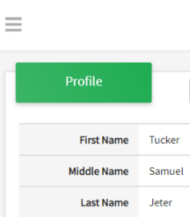
With either option, this will bring up a drop down list to begin adding Animals.

Adding an Animal
- Click "Add an Animal"
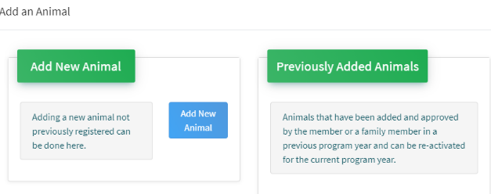Then select “Add New Animal”
- Select Llama/Alpaca, from the drop down. REQUIRED: Enter Animal Tattoo or “000”, if unknown, click “Save”
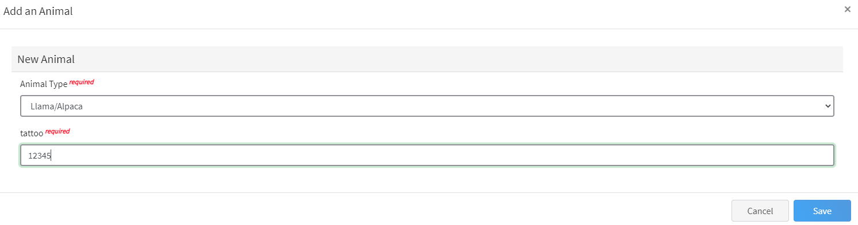
- Next, click “Show Questions”
Animal Entry is open for the current enrollment year. - Is all information complete? Check all county animal entry deadlines.
READ All County instructions for each animal species as county requirements vary.
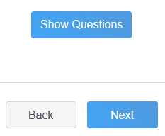
- Enter the animal’s name. This would be the Animal Common Name or Barn Name
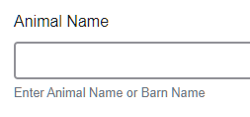

- Fill in a description of the animal’s colors and markings.
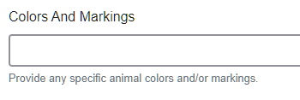
- Enter Premises or Location ID, if applicable in your county.
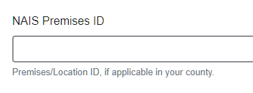
- Enter whether you own or lease the animal.
- Enter the purchase or lease date.
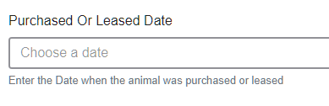
- Enter the Animal Gender – male or female.

- The Tattoo or Brand will be brought over from the first screen, as this is required. This field can be updated to reflect the correct tattoo of the animal.
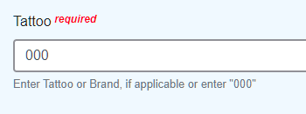
- Click “Next”, continue with the “File Uploads” that are required by your local county extension office. These will vary by county and species. Please follow all your county guidelines.
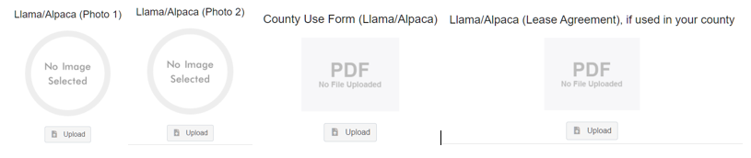

- Confirm all information, click ‘submit’
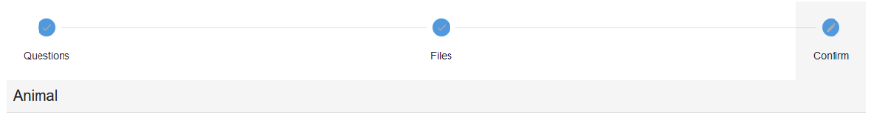
- County Extention staff, will review all information. If more is needed, members can edit. Once “Approved” by your local county extension office an email will be sent to your family account (example below) A time and date stamp for each animal.
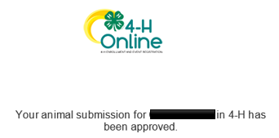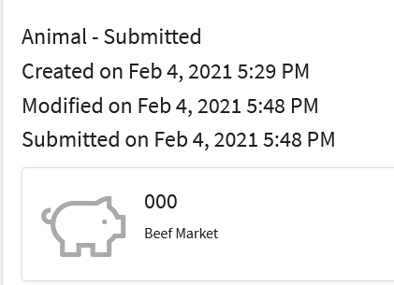
Questions, please contact your local extension staff.

